

LAB SETUP FOR NETWORK AUTOMATION

VMWARE- UBUNTU



September 10, 2020

wipro technologies

Bangalore, India

Table of Contents

S.NO TOPIC NAME P.NO

1. Install Ubuntu on Vmware………………………………………………………………………………………………………………..2

2. Install GNS3 on Ubuntu…………………………………………………………………………………………………………………….3

3. Download IOS image of router for gns3……………………………………………………………………………………………4

4. Install IOS image of router in gns3……………………………………………………………………………………………………5

5. Create Virtual Environment on Ubuntu……………………………………………………………………………………………9

6. Installing required Libraries……………………………………………………………………………………………………………10

7. Integrating gns3 with local machine……………………………………………………………………………………………….12

# Install Ubuntu On Vmware

To Install ubuntu on vmware follow this link

* <https://www.youtube.com/watch?v=AlOcHa_KB0k>

# Install GNS3 On Ubuntu

To install GNS3 on ubuntu follow this link

* <https://www.linuxhelp.com/install-gns3-ubuntu-16-04>

# Download IOS image of router for gns3

* Click on the below link
  + <https://drive.google.com/drive/folders/1IdZUZuX17ESI--Vj21aCBTTgbEQlS7bQ>
* Download c3725 ios image

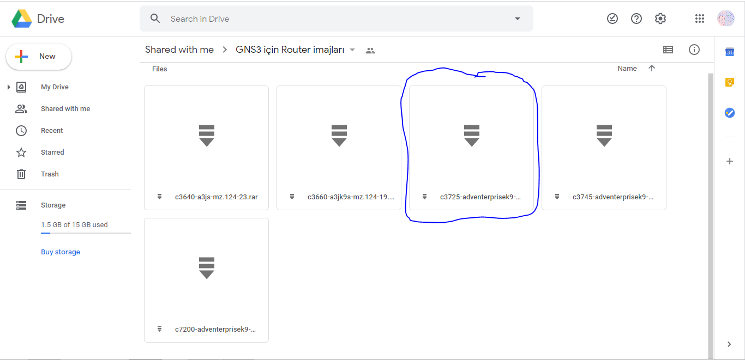

# Install IOS image of router in GNS3

* Open GNS3
* Click Edit and choose IOS images and hypervisors, as shown in fig.

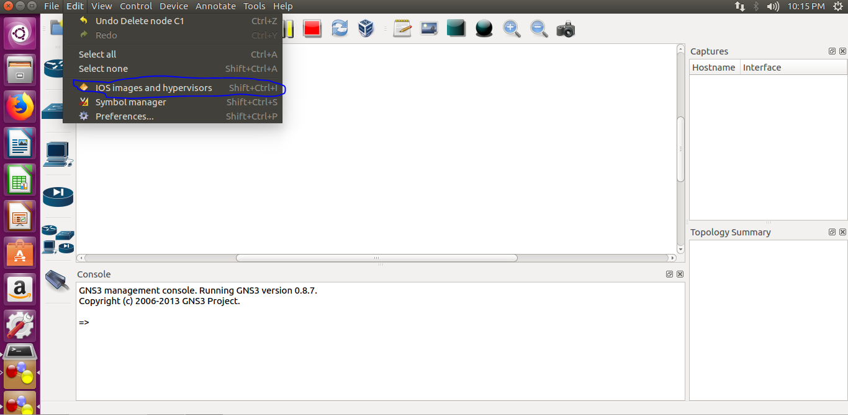

* Click on the browse button, as shown in fig.

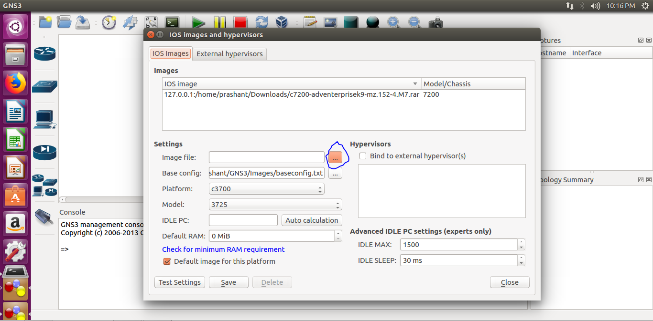

* Navigate to the path where you have downloaded the IOS image

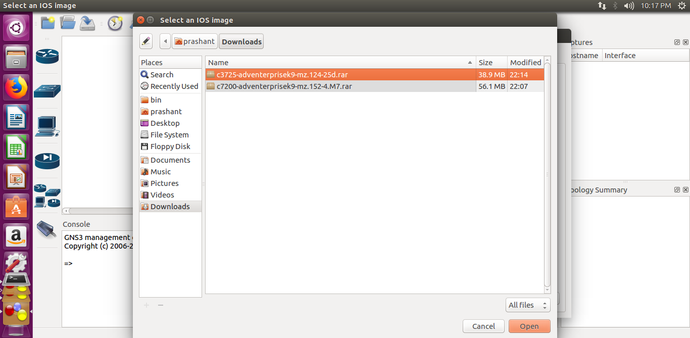

* Click Open
* It will ask to uncompress it, click Yes

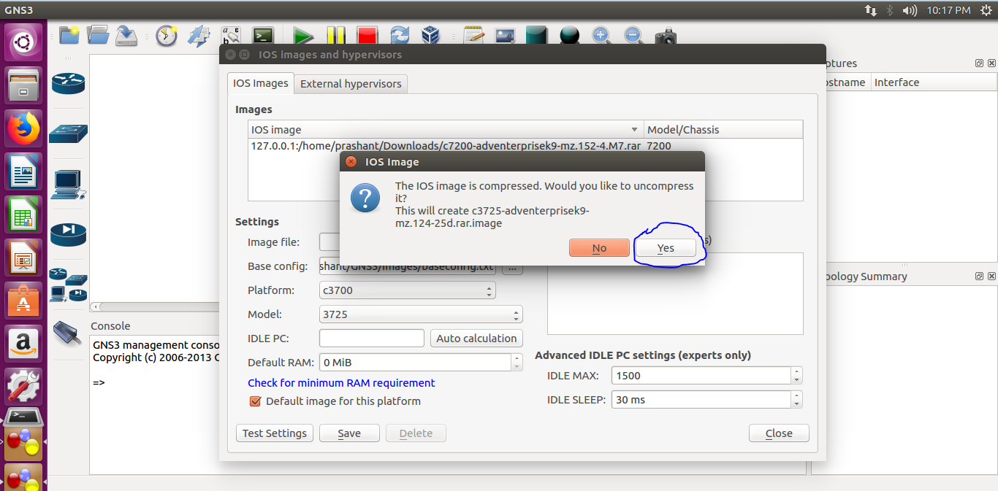

* Click save
* Click Close, You are good to go now.

# Create Virtual Environment On Ubuntu

To create a virtual environment follow this link

* <https://www.liquidweb.com/kb/creating-virtual-environment-ubuntu-16-04/>

# Installing Required Libraries

* Activate your virtual environment
* Install paramiko using command
  + pip install paramiko
* Install Netmiko using command
  + pip install netmiko
* Installing git
  + sudo apt-get update
  + sudo apt-get install git
* Installing TEXTFSM
  + Create a folder TEXTFSM_GIT
  + Come in TEXTFSM_GIT directory
  + Give the below command
  + git clone https://github.com/networktocode/ntc-templates.git

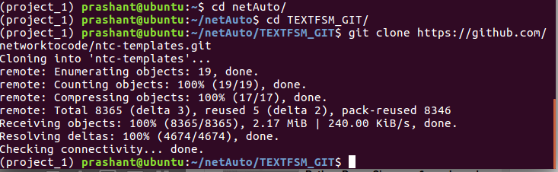

* + copy the path of templates folder present inside ntc-templates folder

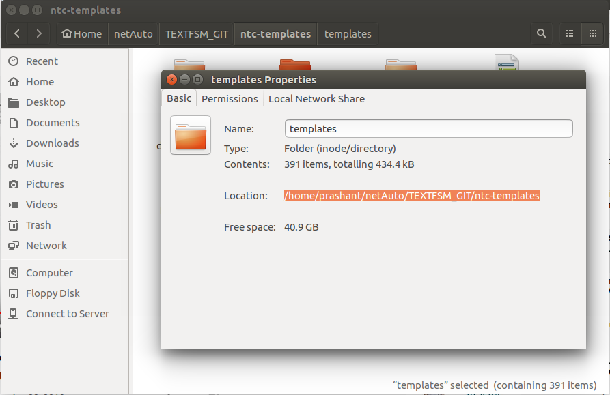

* + paste it in front of export command as shown in figure



* Install NAPALM library using command
  + pip install NAPALM

# Integrating GNS3 with local machine

* Open vmware and click edit virtal machine settings

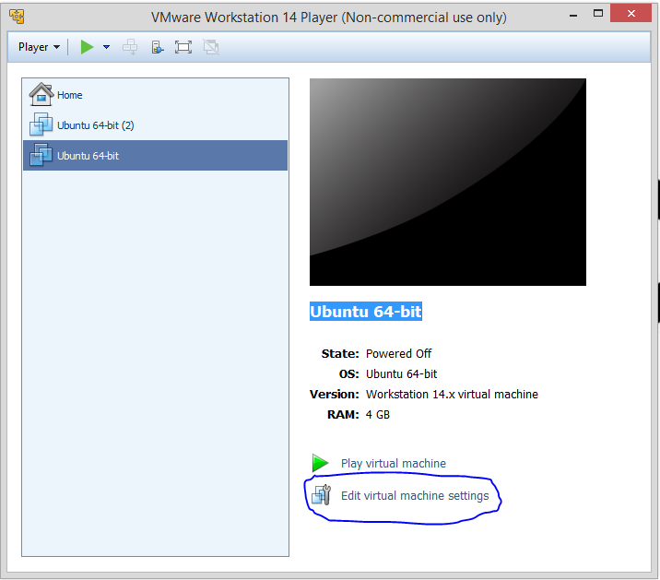

* Choose NAT in network adapters

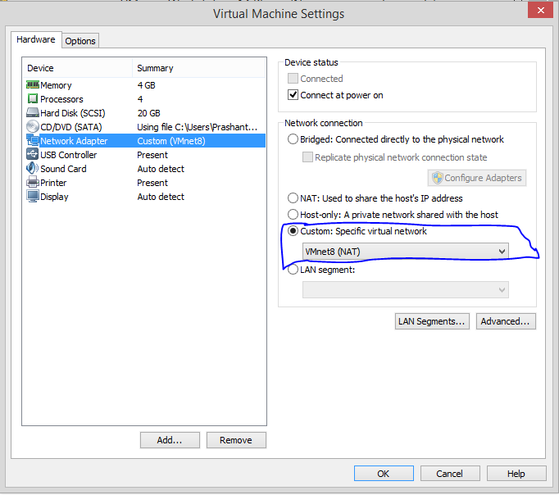

* After this, open network and sharing center in control panel on your operating system, goto change adapter settings
* Click on VMNet8, right click and choose properties

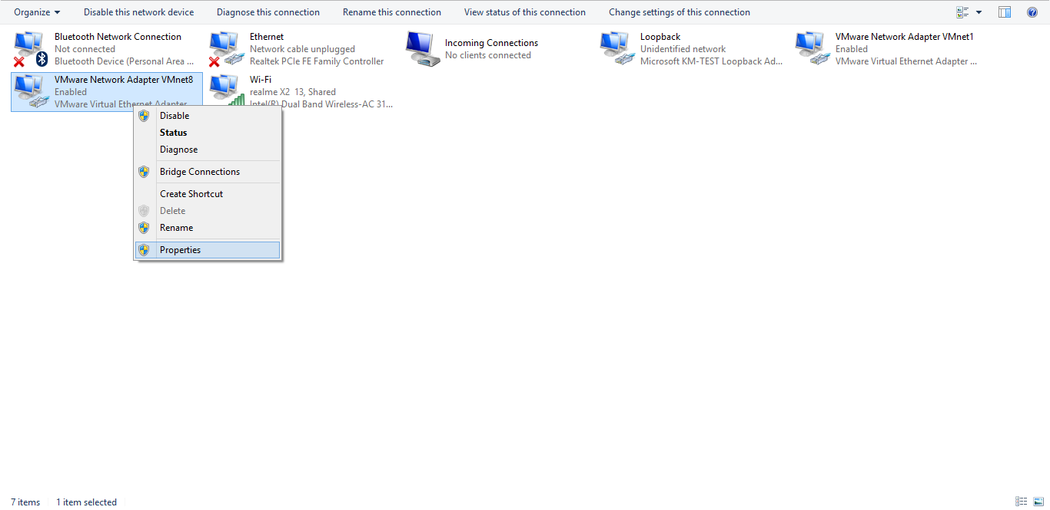

* Choose IPV4 and click on properties

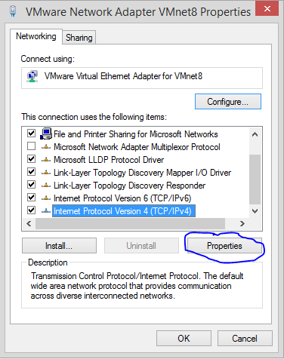

* Configure gateway and DNS according to your need

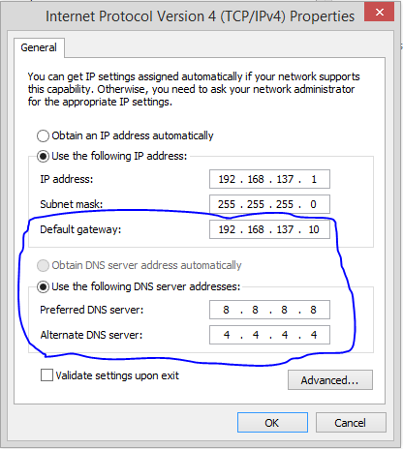

* It’s done